Constructing Circle

Definition
# Source: AI Source: Provided by: [Data Path: Persons Table -> ID Column: 1, Name_En Column: Motasem Essam] -> From: [ChatGPT] on [7/25/2026]
Constructing a Circle is the geometric construction of a circle from specified geometric information, most commonly its center and radius, using a compass.
A circle with center $O$and radius $r$is the set of all points that are exactly $r$units from $O$.
$$\boxed{OP=r}$$
for every point $P$on the circle.
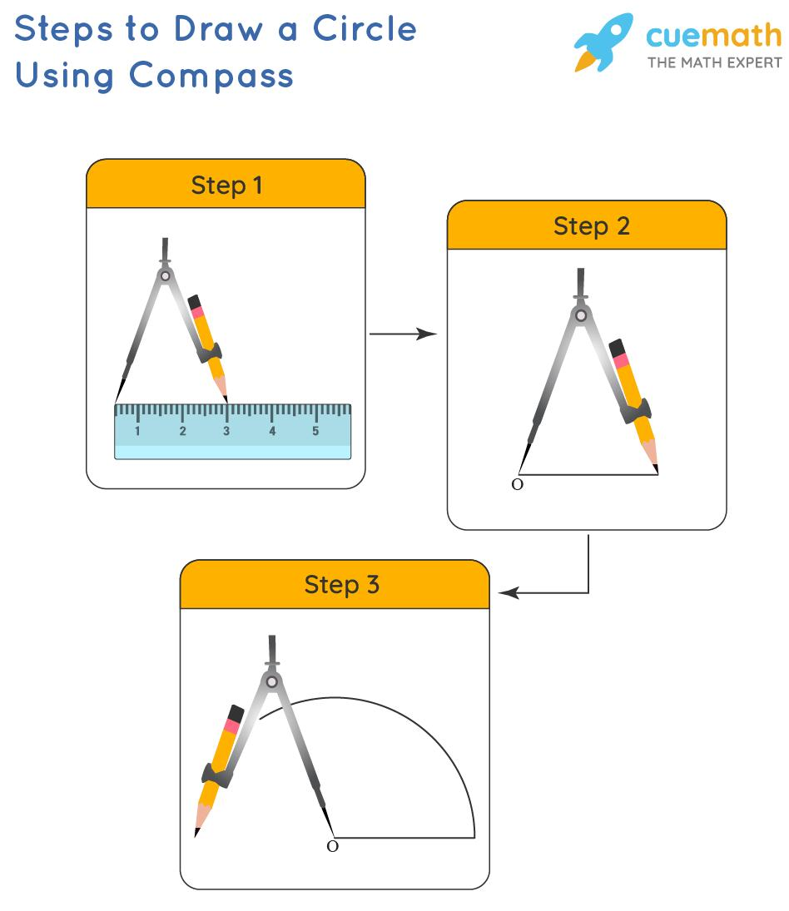
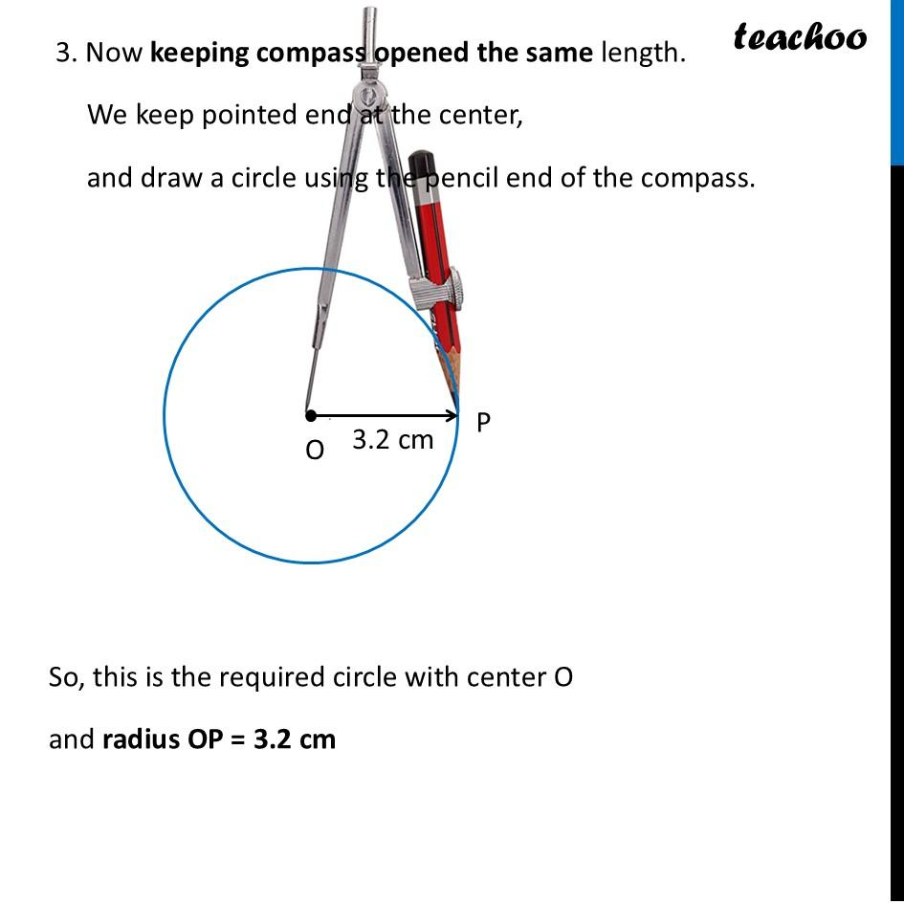
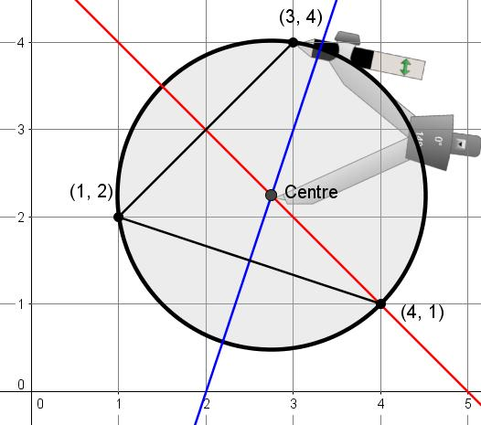
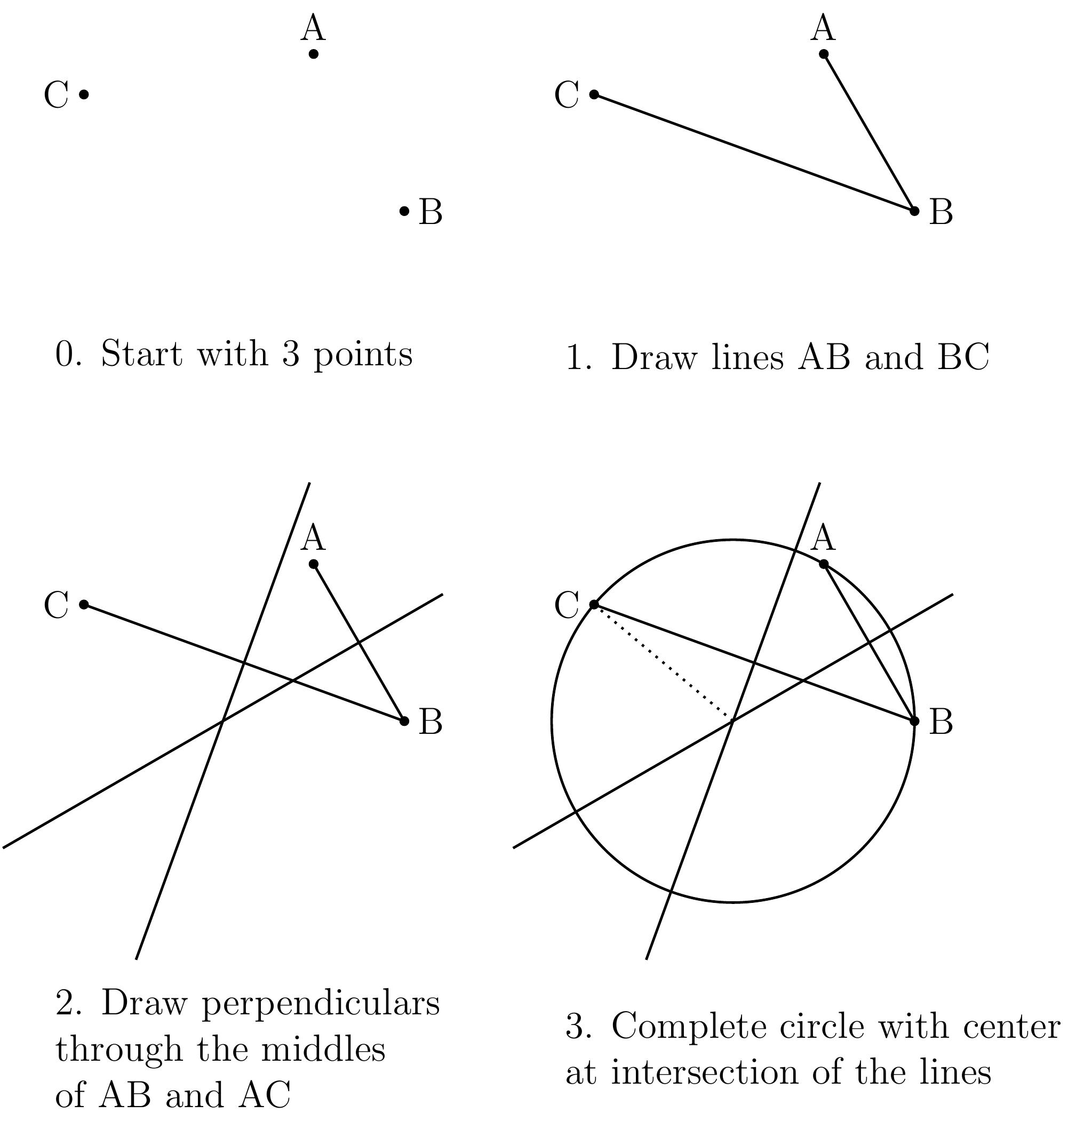

Fundamental Concept
# Source: AI Source: Provided by: [Data Path: Persons Table -> ID Column: 1, Name_En Column: Motasem Essam] -> From: [ChatGPT] on [7/25/2026]
A circle is uniquely determined by its:
- Center
- Radius
If $O$is the center and $r$is the radius:
$$\boxed{\text{Circle}=\left(O , r\right)}$$
The compass is the fundamental tool because it can maintain a fixed distance while rotating around a center.

Basic Construction: Circle Given Center and Radius
# Source: AI Source: Provided by: [Data Path: Persons Table -> ID Column: 1, Name_En Column: Motasem Essam] -> From: [ChatGPT] on [7/25/2026]
Suppose the center $O$and radius $r$are given.
Steps
- Mark the center $O$.
- Set the compass opening to the required radius $r$.
- Place the compass point at $O$.
- Rotate the compass around $O$, keeping the compass width fixed.
- Complete the circular curve.
The resulting circle has:
$$\boxed{\text{Center}=O}$$
and:
$$\boxed{\text{Radius}=r}$$
Representation

●
. .
. .
. O .
. .
. .
●
Every point on the circle is the same distance from $O$.

Mathematical Representation
# Source: AI Source: Provided by: [Data Path: Persons Table -> ID Column: 1, Name_En Column: Motasem Essam] -> From: [ChatGPT] on [7/25/2026]
For a circle centered at $O\left(h , k\right)$with radius $r$:
$$\boxed{{\left(x-h\right)}^{2}+{\left(y-k\right)}^{2}=r^{2}}$$
For a circle centered at the origin:
$$\boxed{x^{2}+y^{2}=r^{2}}$$

Types of Circle Construction
# Source: AI Source: Provided by: [Data Path: Persons Table -> ID Column: 1, Name_En Column: Motasem Essam] -> From: [ChatGPT] on [7/25/2026]
The main construction situations can be organized as follows:
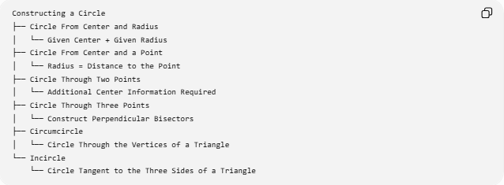
Constructing a Circle
├── Circle From Center and Radius
│ └── Given Center + Given Radius
├── Circle From Center and a Point
│ └── Radius = Distance to the Point
├── Circle Through Two Points
│ └── Additional Center Information Required
├── Circle Through Three Points
│ └── Construct Perpendicular Bisectors
├── Circumcircle
│ └── Circle Through the Vertices of a Triangle
└── Incircle
└── Circle Tangent to the Three Sides of a Triangle
Important: Two points alone do not uniquely determine a circle. Infinitely many circles can pass through two given points. Additional information, such as the center or a third point, is required.

1. Circle From Center and Radius
# Source: AI Source: Provided by: [Data Path: Persons Table -> ID Column: 1, Name_En Column: Motasem Essam] -> From: [ChatGPT] on [7/25/2026]
This is the fundamental circle construction.
Given:
$$O, r$$
construct:
$$\boxed{\text{Circle}\left(O , r\right)}$$
The compass is set to $r$and rotated around $O$.

2. Circle From Center and a Point
# Source: AI Source: Provided by: [Data Path: Persons Table -> ID Column: 1, Name_En Column: Motasem Essam] -> From: [ChatGPT] on [7/25/2026]
Suppose the center $O$and a point $A$on the circle are given.
The radius is:
$$\boxed{r=OA}$$
Steps
- Place the compass point at $O$.
- Set the compass width to $OA$.
- Rotate the compass around $O$.
- The resulting circle passes through $A$.
Therefore:
$$\boxed{OA=OP=r}$$
for every point $P$on the circle.

3. Circle Through Three Given Points
# Source: AI Source: Provided by: [Data Path: Persons Table -> ID Column: 1, Name_En Column: Motasem Essam] -> From: [ChatGPT] on [7/25/2026]
Three non-collinear points uniquely determine a circle.
Suppose $A$, $B$, and $C$are given.
Construction
- Construct the perpendicular bisector of:
$$\overset{‾}{AB}$$
- Construct the perpendicular bisector of:
$$\overset{‾}{BC}$$
- Let the two perpendicular bisectors intersect at $O$.
- $O$is the center of the circle.
- Set the compass radius to $OA$.
- Draw the circle centered at $O$.
Because:
$$OA=OB=OC$$
the circle passes through all three points.
$$\boxed{A,B,C\text{ lie on the same circle}}$$
Why It Works
The perpendicular bisector of $AB$contains every point equidistant from $A$and $B$.
Therefore, for the center $O$:
$$OA=OB$$
Similarly, because $O$lies on the perpendicular bisector of $BC$:
$$OB=OC$$
Thus:
$$\boxed{OA=OB=OC}$$
So $O$is the center of the circle through $A$, $B$, and $C$.

4. Constructing a Circumcircle
# Source: AI Source: Provided by: [Data Path: Persons Table -> ID Column: 1, Name_En Column: Motasem Essam] -> From: [ChatGPT] on [7/25/2026]
A circumcircle is a circle passing through all three vertices of a triangle.
For:
$$△ABC$$
the circumcircle passes through:
$$A, B, C$$
Its center is the circumcenter.
Construction
- Construct the perpendicular bisector of $AB$.
- Construct the perpendicular bisector of $AC$.
- Find their intersection $O$.
- Use $OA$as the radius.
- Draw the circle centered at $O$.
Therefore:
$$\boxed{OA=OB=OC}$$
and the resulting circle is the circumcircle.

5. Constructing an Incircle
# Source: AI Source: Provided by: [Data Path: Persons Table -> ID Column: 1, Name_En Column: Motasem Essam] -> From: [ChatGPT] on [7/25/2026]
An incircle is a circle inside a triangle that is tangent to all three sides.
For:
$$△ABC$$
the center of the incircle is the incenter.
Construction
- Construct the angle bisector of $∠A$.
- Construct the angle bisector of $∠B$.
- Find their intersection $I$.
- Construct a perpendicular from $I$to one side, such as $AB$.
- Let the perpendicular distance be $r$.
- Draw the circle centered at $I$with radius $r$.
Then the circle is tangent to all three sides.
$$\boxed{\text{Incenter}=\text{intersection of the angle bisectors}}$$
and:
$$\boxed{r=d\left(I , \text{each side}\right)}$$

Circle Construction vs Circular Region
# Source: AI Source: Provided by: [Data Path: Persons Table -> ID Column: 1, Name_En Column: Motasem Essam] -> From: [ChatGPT] on [7/25/2026]
A circle and a circular region are different geometric objects.
Circle
The circle is the boundary:
$$\boxed{{\left(x-h\right)}^{2}+{\left(y-k\right)}^{2}=r^{2}}$$
Circular Region
The filled region inside and including the circle is represented by:
$$\boxed{{\left(x-h\right)}^{2}+{\left(y-k\right)}^{2}≤r^{2}}$$
Therefore:
$$\boxed{\text{Circle}=\text{Boundary}}$$
while:
$$\boxed{\text{Circular Region}=\text{Interior Region}}$$
Circle vs Disk
A disk normally refers to the filled circular region bounded by a circle.
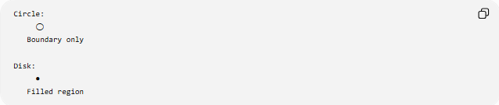
Circle:
◯
Boundary only

Disk:
●
Filled region

Important Circle Properties
# Source: AI Source: Provided by: [Data Path: Persons Table -> ID Column: 1, Name_En Column: Motasem Essam] -> From: [ChatGPT] on [7/25/2026]
Radius
The distance from the center to any point on the circle:
$$\boxed{r}$$
Diameter
A chord passing through the center has length:
$$\boxed{d=2r}$$
Circumference
$$\boxed{C=2πr}$$
Area of the Circular Region
$$\boxed{A=πr^{2}}$$
The area belongs to the circular region, not to the one-dimensional circle boundary itself.

Special Circle Constructions
# Source: AI Source: Provided by: [Data Path: Persons Table -> ID Column: 1, Name_En Column: Motasem Essam] -> From: [ChatGPT] on [7/25/2026]
Some common constructions involving circles include:
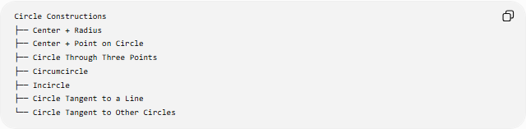
Circle Constructions
├── Center + Radius
├── Center + Point on Circle
├── Circle Through Three Points
├── Circumcircle
├── Incircle
├── Circle Tangent to a Line
└── Circle Tangent to Other Circles
The last two are more advanced construction problems because additional geometric conditions determine the required center and/or radius.
Circle Tangent to a Given Line
If a circle must be tangent to a line $l$, the radius to the point of tangency is perpendicular to the line:
$$\boxed{OP⊥l}$$
where $P$is the point of tangency.
Thus, perpendicular-line construction can be used as part of the circle construction.
Circle Tangent to Two Lines
For a circle tangent to two intersecting lines, its center lies on an angle bisector of the angle formed by the lines.
Therefore, constructing an angle bisector can be part of the construction.
This connects circle construction with:
- perpendicular lines
- angle bisectors
- perpendicular bisectors

Tools Used
# Source: AI Source: Provided by: [Data Path: Persons Table -> ID Column: 1, Name_En Column: Motasem Essam] -> From: [ChatGPT] on [7/25/2026]
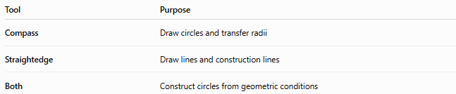
Tool | Purpose
Compass | Draw circles and transfer radii
Straightedge | Draw lines and construction lines
Both | Construct circles from geometric conditions
The compass is the primary tool for drawing a circle.

Relationship to Other Geometric Constructions
# Source: AI Source: Provided by: [Data Path: Persons Table -> ID Column: 1, Name_En Column: Motasem Essam] -> From: [ChatGPT] on [7/25/2026]
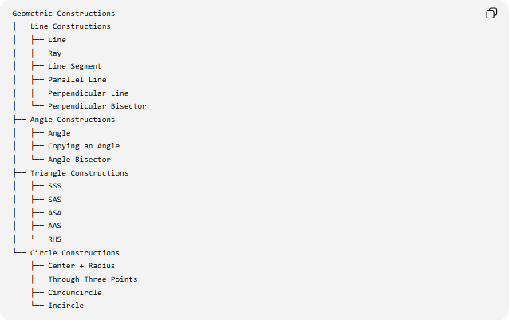
Geometric Constructions
├── Line Constructions
│ ├── Line
│ ├── Ray
│ ├── Line Segment
│ ├── Parallel Line
│ ├── Perpendicular Line
│ └── Perpendicular Bisector
├── Angle Constructions
│ ├── Angle
│ ├── Copying an Angle
│ └── Angle Bisector
├── Triangle Constructions
│ ├── SSS
│ ├── SAS
│ ├── ASA
│ ├── AAS
│ └── RHS
└── Circle Constructions
├── Center + Radius
├── Through Three Points
├── Circumcircle
└── Incircle
Circle construction often combines several basic constructions.
For example:
$$\boxed{\text{Circle Through 3 Points}=\text{Perpendicular Bisectors}+\text{Compass}}$$
And:
$$\boxed{\text{Incircle}=\text{Angle Bisectors}+\text{Perpendicular}+\text{Compass}}$$

Classification Summary
# Source: AI Source: Provided by: [Data Path: Persons Table -> ID Column: 1, Name_En Column: Motasem Essam] -> From: [ChatGPT] on [7/25/2026]
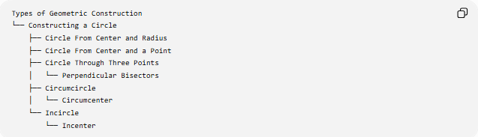
Types of Geometric Construction
└── Constructing a Circle
├── Circle From Center and Radius
├── Circle From Center and a Point
├── Circle Through Three Points
│ └── Perpendicular Bisectors
├── Circumcircle
│ └── Circumcenter
└── Incircle
└── Incenter

Key Points
# Source: AI Source: Provided by: [Data Path: Persons Table -> ID Column: 1, Name_En Column: Motasem Essam] -> From: [ChatGPT] on [7/25/2026]
- A circle is determined by its center and radius.
- The compass is the primary tool for constructing a circle.
- Every point on a circle is the same distance from its center:
$$\boxed{OP=r}$$
- Two points alone do not uniquely determine a circle.
- Three non-collinear points uniquely determine a circle.
- The circle through the vertices of a triangle is its circumcircle.
- The circle tangent to all three sides of a triangle is its incircle.
- The circumcenter is found using perpendicular bisectors.
- The incenter is found using angle bisectors.
- A circle is the boundary, while a circular region is the corresponding filled region.

Conclusion
# Source: AI Source: Provided by: [Data Path: Persons Table -> ID Column: 1, Name_En Column: Motasem Essam] -> From: [ChatGPT] on [7/25/2026]
Constructing a Circle is the process of creating a circle from specified geometric information, most fundamentally a center and radius, using a compass. More advanced constructions can determine a circle from three non-collinear points, construct a triangle's circumcircle, or construct its incircle. These constructions connect the circle with fundamental geometric constructions such as perpendicular bisectors, angle bisectors, perpendicular lines, and line segments.

